**INHERITANCE**

**THEME: GENETICS**

**TOPIC: INHERITANCE**

By the end of this Chapter; the Learner should;

* Understand the process of Cell division and significance of meiosis.
* Understand the concept of inheritance using genetic diagrams.
* Understand and explain sex determination and sex linkage in humans.

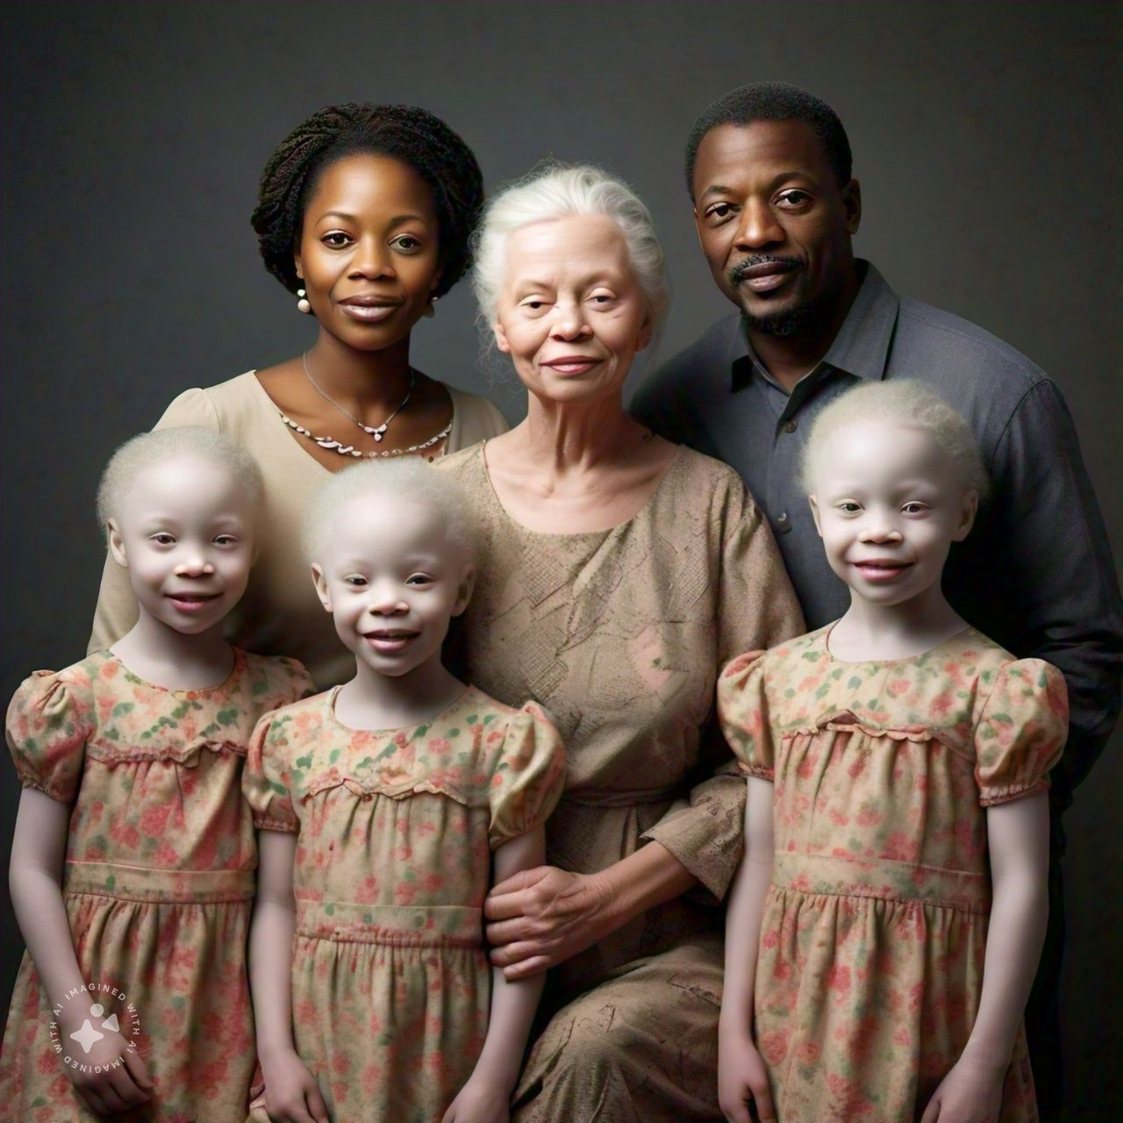

*Fig. 1 shows a nuclear family where the grandparent was Albino, daughter is a carrier, son in-law is normal, all daughters are Albino.*

**HEREDITY** **IN ORGANISMS**

The term "heredity" refers to the passing down of traits or characteristics from parents to offspring through the transmission of genetic information. It's the concept that the characteristics of an individual are influenced by the genetic factors inherited from their parents.

In the context of inheritance, heredity refers to the way in which traits are passed down from one generation to the next. This can include physical characteristics, such as eye color, hair color, and height, as well as susceptibility to certain diseases or conditions.

In genetics, heredity is the study of how genes are transmitted from parents to offspring and how they influence the development and traits of an individual. It involves the study of genes, chromosomes, and other genetic factors that determine the characteristics of an individual.

**Examples of heredity include:**

- A child inheriting their parent's blue eyes or curly hair

- A family history of a certain disease, such as sickle cell anemia or cystic fibrosis

- A person's height or facial features being similar to those of their parents or grandparents.

**CELL DIVISION PROCESS**

**Cell division is a process by which a cell divides to give rise to daughter cells.**

During cell division, the nucleus divides into two followed by the division of the cytoplasm. The cell membrane constricts to surround the formed cells each containing a nucleus. This results into formation of daughter cells. There are two types of cell division; **MITOSIS and MEIOSIS.**

**Commonly used terms in Cell Division.**

1. **A Chromosome** is a thread like molecule in the nucleus on which the genes are carried.
2. **A gene** is a basic unit of inheritance for a given trait eg Height, Skin Colour, Eye colour etc.
3. **An allele** is one of the alternative forms of the same gene responsible for determining contrasting traits eg. Tallness, Dark skin, Blue eyes, red colour blindness etc.
4. **Dominant allele (eg.** T) is an allele whose trait is expressed in the phenotype of a heterozygote.
5. **Recessive allele (eg. t)** is an allele whose trait is suppressed in the phenotype of a heterozygote but Expressed only in the phenotype of a homozygote.
6. **A Homozygote** is an organism whose given gene consists of identical alleles in the genotype eg. TT or tt.
7. **A Heterozygote** is an organism whose given gene consists of different alleles in the genotype eg. Tt.
8. **A genotype** is a genetic composition in the cell of an organism that causes traits to be expressed eg TT, Tt, Hh,hh,tt or PP etc.
9. **A phenotype** is an observable trait of an organism caused by it’s genetic composition.

**MITOSIS**

This is a type of cell division where a cell divides to give rise to two daughter cells each having the same number of chromosomes as the parent cell and each having exactly the same number of chromosomes as the parent cell.

Cell Division occurs in a cell in Four Stages; before they start, the cell undergoes **Interphase. This** is a Preparation stage through which the following Processes occur:

* Chromosomes are drawn into long threads of chromatids.
* The genetic material or chromosomes replicate to ensure similar genetic Information for the two cells.
* The cell manufactures and stores energy through respiration in preparation for cell division.
* The centrioles replicate if present.

During the Second stage; **Prophase**

* **The nuclear membrane disintegrates and disappears towards the end of**

**Prophase.**

* Each Chromosome divides into two Chromatins lying parallel to each other and attached together at the centromere.
* The Nucleolus disappears
* The centromeres migrate to opposite poles and begin to produce spindle fibers which form a spindle equator at the center.
* The nuclear membrane disintegrates and disappears towards the end of prophase.

During the Second Stage; **Metaphase:**

* The Chromosomes move to the center of the cell and arrange themselves at the spindle equator.
* Sister chromatids face opposite poles of the spindle fibers.

During the Third Stage, **Anaphase:**

* Centromeres divide and the two chromatids of each chromosome move to opposite poles.
* Each chromatid now becomes a chromosome.
* Spindle fibers shorten as they pull the chromatids apart.

During the Fourth Stage, **Telophase:**

* The Chromosomes reach and settle at the poles.
* The cell divides by constriction of the cell membrane in animals or by forming a cell wall plate in plants.
* The nuclear membrane reappears in each new cell.
* The nucleolus also reappears in each new cell.
* Spindle fibers disappear.

**Meiosis**

**Meiosis** is the type of cell division that results into the formation of four daughter cells with half the number of chromosomes in the parent cell.

**OR**

**Meiosis** is a form of cell division in which a diploid cell divides into four haploid daughter cells.

**EVENTS THAT OCCUR DURING MEIOSIS**

Before cell division begins, the Cell undergoes a preparatory process called **Interphase.** During this Preparation;

* The DNA (Chromosomes) replicates to form another copy of itself.
* More energy in form of ATP to facilitate the division process is manufactured by mitochondria.
* Most cell organelles replicate (such as the centrioles, mitochondria, and chloroplast) but not the nucleus.
* The Chromosomes become thinner and invisible (this form is called Chromatin)

Meiosis occurs in two steps; MEIOSIS 1 and MEIOSIS 2. Each of these steps occurs in four stages, I.e. Prophase, Metaphase, Anaphase and Telophase.

**STEP 1 (Meiosis I)**

**Stages**

**Prophase I**

* The Chromosomes shorten and become visible (at this point, each is made of a pair of sister Chromatids)
* Homologous chromosomes pair up; one from the male parent and the other from the female parent. These carry the same genes.
* Homologous chromosomes join at points called **chiasmata, where** they break and reunite to have genes from each chromosome crossover to the other and they are exchanged.
* The nucleus and the nucleolus disappear and spindle fibres form

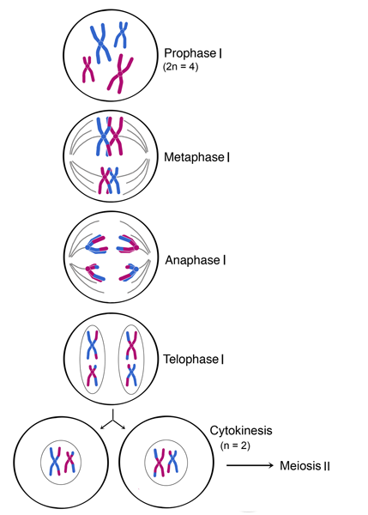

**Metaphase I**

* The pair of chromosomes in which crossing over has occurred arrange themselves around the middle of the cell, at the equator of the cell.

**Anaphase I**

* **Spindle** fibres pull the homologous Chromosomes apart towards each opposite poles forming two haploid sets.

**Telophase I**

* Homologous chromosomes arrive at opposite poles. They are now haploid sets but each chromosome is still made of two sister Chromatids.
* The nucleus reappears and in animals, the cell pinches inwards to divide the cytoplasm to form two daughter cells while in plants, the cell wall formation occurs.

After the first step, it may be necessary for the cells to undergo another interphase, a Preparation stage but this usually happens only in animal cells but this time, there’s no replication of DNA.

**STEP II (Meiosis II)**

**Stages**

**Prophase II**

* The Chromosomes shorten and become visible. (Still made of sister chromatids)
* The nucleus and the nucleolus disappear and spindle fibres form.
* Centrioles move to the opposite poles as guided by the spindle fibres.

**Metaphase II**

* Chromosomes line up separately around the equator of the spindle fibres.

**Anaphase II**

* **The** centromeres divide and the spindle fibres pull the chromatids to opposite poles, with centromeres in leading.

**Telophase II**

* The chromatids arrive at the opposite poles, they uncoil and become invisible.
* Spindle fibres disappear and centrioles replicate.
* The nuclear membrane and nucleolus reappear.

**The** cell pinches inwards to divide the cytoplasm (in animal) or cell wall formation occurs (in plants). Finally, four daughter cells from the original single parent cell are formed.

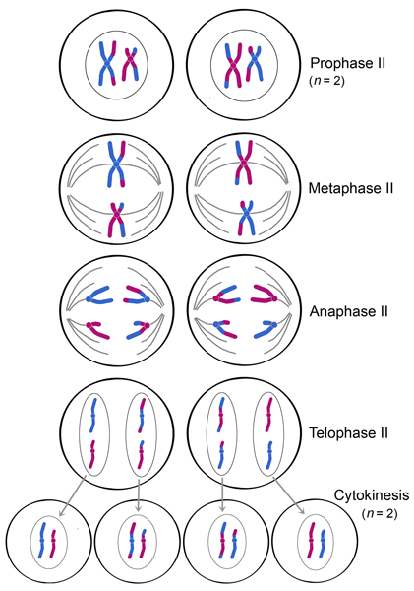

**SIGNIFICANCE OF MEIOSIS**

Meiosis is crucial for sexual reproduction and has several significant consequences:

1. Genetic diversity: Meiosis shuffles and recombines genetic material, increasing genetic diversity among offspring, which helps populations adapt to changing environments.
2. Crossing over and recombination: Meiosis allows for the exchange of genetic material between homologous chromosomes, increasing genetic variation.
3. Random assortment: Meiosis randomly sorts chromosomes, further increasing genetic diversity.
4. Sexual reproduction: Meiosis enables sexual Reproduction by allowing the diploid set in the body cells to be halved into the haploid set in gametes which then become diploid again after fertilization.

**GENETIC DIAGRAMS**

These are illustrative diagrams that show how alleles are passed down to the offspring from parents. Each allele is represented by a symbolic letter e.g. T for tallness and t for shortness, A for albinism and a for a normal condition. Etc.

Scenario 1: Aaron, rich man in Kamwenge rears rabbits and sells them to a nearby restaurant for money. In his cage are Rabbits with black fur and those with grey fur. One season, Aaron decided to separate the grey from the black rabbits and they all kept on giving birth to grey and black rabbits respectively. When he allowed the black male rabbit to mate with the grey haired one, all of the offspring had black fur.

Task 1: Using genetic diagrams, explain the findings of Aaron when he had all offspring with black fur.

*Since the black rabbits produce black ones when they mate with grey rabbits, it means that the Black fur allele is dominant*

*Let the allele for black fur be B*

*Let the allele for grey fur be b*

*Since the dominant allele B is present in every gamete formed, all the offspring will be Black.*

Task 2: Using genetic diagrams explain what would happen if Aaron allowed these black offspring to mate with themselves.

(*Still considering the alleles B and b)*

Scenario 2: On determining the genotype of Mr. KASIM, it is realized that he is homozygous for the dominant allele of tallness but his wife is homozygous for shortness. Their son, Patrick always wondered why he is tall yet his mother is short. Moreover all his siblings are tall.

Task: Since tallness and shortness are different alleles that give an Expression of the Gene of Height; explain to Patrick his condition, using genetic diagrams.

Let *the allele for tallness be T*

*Let the allele for shortness be t*

*Expln****:*** *Since the man tested homozygous for the dominant gene, TT, all his offspring shall be tall.*

**INCOMPLETE DOMINANCE AND CO-DOMINANCE**

**CO-DOMINANCE** is a situation when two or more alleles of the same gene dominate and result into a phenotype that shows a combination of both.

Examples include:

* Blood types in humans; A, B, AB and o, a person with allele for A blood and an allele for B blood has blood type AB.
* When a chicken with white feathers breeds with a chicken with black feathers, an offspring chicken will have both white and black feathers.

Incomplete dominance is a situation when two alleles of the same gene become neither dominant nor recessive but results into a phenotype that is a blend of both alleles. Such as:

* A true breeding red flower and a true breeding white flower results in an offspring with pink flowers.

In co-dominance both alleles dominate which results into a phenotype that shows a combination of both.

Scenario: A genetist named *Gregor Mendal* artificiallyallowed red flower pea plants to pollinate those with pink flowers. He did this because he was curious about the way how characteristics are passed from one generation to another. This experiment produced an offspring with only pink flowers. This result was too complicated for Gregor to cogitate.

Task: Using genetic diagrams and suitable symbols explain the results to Gregor and tell him how the pink colour comes about. State the resultant phenotypic ratio.

*Let the allele for red flowers be R*

*Let the allele for white flowers be W*

*In case the F1 generation is selfed, a mixture of red, pink and white flowers pea plants will be given as the offspring.*

***F1 Selfed***

**NB:** The phenotypic ratio differs from that of simple genetics (**Complete dominance**); the F2 generation offspring becomes 1:2:1 instead of 3:1.

**SEX DETERMINATION IN HUMANS**

In humans, sex is determined by the X and Y chromosomes. These two form the last pair among the 23 pairs in human cells. In females, this last pair is made up of X and X Chromosomes while in males, it is X and Y chromosomes.

During sperm formation, each sperm carries on of either X or Y but the ovum carries specifically the X chromosome only in females. During fertilization, if, by chance the sperm carrying the Y chromosome enters the ovum first, the child becomes a boy (X with Y) and if this sperm is the one carrying the X chromosome, the child becomes a girl (X and X).

In humans, the chance of giving birth to a boy or a girl is 50% and this is determined but not controlled by the male parent. It **cannot** be controlled. It’s totally by chance.

Scenario: Charles IV, the king of England is at the verge of dying without having an heir to fill his throne. Diana, an apprentice in the kingdom happens to fall in love with the king and becomes pregnant. The conspiracy unravels and the committee decides that if a girl is born, she will be killed in order to protect the legacy of the loyal family but if it’s a boy, he will be granted life, made a prince and his mother made queen.

Task: Calculate the percentage chance for the baby being a boy. Use genetic diagrams.

*In this case we don’t let the alleles to be a certain symbol because sex has its own special symbols X and Y.*

*Percentage chance of Number of boys X 100*

*Producing a boy = Number of chances*

*= 2 Boys X 100*

*4 Chances*

*= 50%*

*Conclusion****: The chance for the child being a boy is equally available as that of the child being a girl.***

**SEX LINKAGE**

Linkage is a situation when genes responsible for certain traits are located on the same chromosome and are therefore inherited together.

**Sex linkage** is a situation where the genes responsible for certain traits are located on the sex chromosomes usually X, such that they must only be inherited by people of the same sex. They include red-green colour blindness, premature balding and haemophilia in males.

Scenario: In cats, the genes controlling the coat colour are carried on the X chromosomes and are co-dominant. A black coat female mated with an orange-coat male produced a litter consisting of black male and tortoise-shell female (orange with black patches) kittens.

Task: Using genetic diagrams and suitable symbols, explain the results. State the resultant phenotypic ratio.

*Let the allele for black coat be B*

*Let the allele for orange coat be O*

***The phenotypic ratio of the offspring is*** *2 tortoiseshell females: 2 black coated males.*

Scenario: Hemophilia in humans is controlled by a sex linked Gene on the X Chromosomes. The queen Victoria of UK from 1837 to 1901 was a carrier for haemophilia and her offspring inherited the allele.

Task: Assuming that Prince Albert of Saxe-coburg-gotha whom she got married to was a normal man, show, by use of genetic diagrams and suitable symbols, the chance of having a hemophiliac prince.

*Let the allele for hemophilia be h*

*Let the allele for normal be H*

*The chance that the prince was haemophiliac is 50% since of the two chances of producing a boy, only one chance the boy is normal.*

Scenario: Oscar is a biology teacher at Harvard High School who knows very well that his wife is a carrier for Hemophilia. They gave birth to a baby boy and since then, Oscar has been wondering whether his son is hemophiliac or not. One day, his son got a scratch that went deep into his skin and he bled and this bleeding was severe because his blood failed to clot.

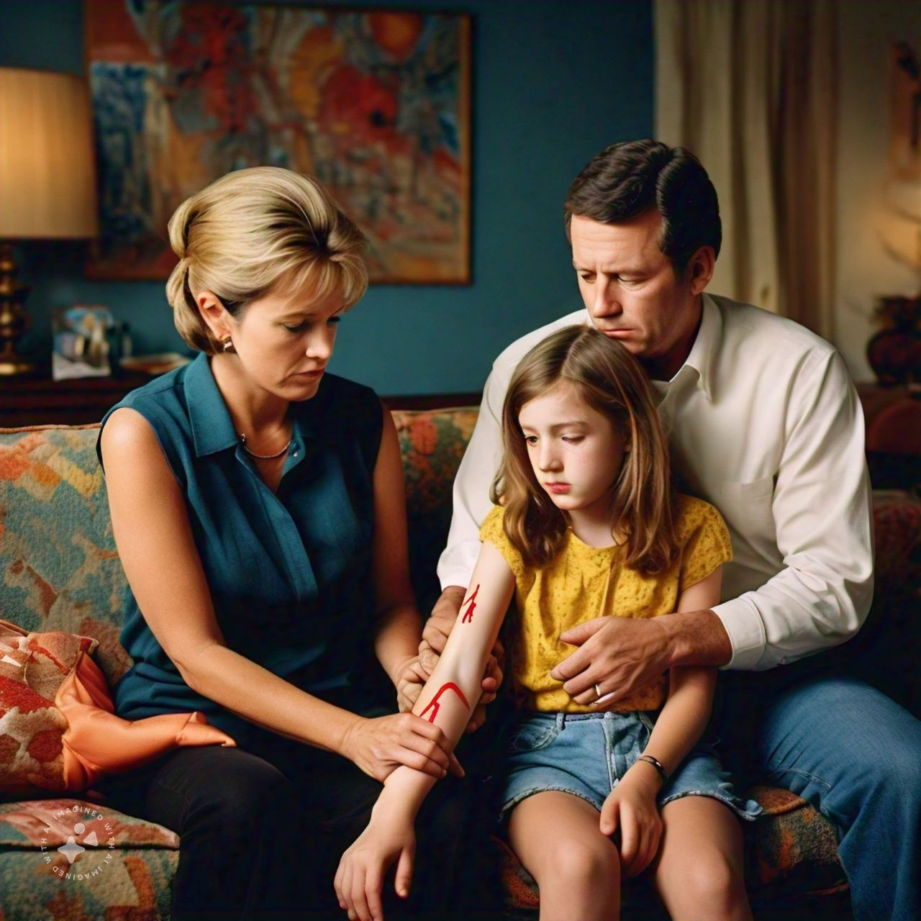

*An image showing a family of a hemophiliac son*

***TASK:***

Using genetic diagrams show how the condition came to their son and suggest a possible solution.

**Sample activity of integration**

People always wonder why sometimes some children resemble / take up the characteristics of one of their parents while others don’t. Some believe that when people stay together for long they start to resemble each other while other people oppose it. There is also a belief that failure to produce a boy is the mother’s fault. Some of these issues have caused conflicts in families.

**Task:**

As a genetist write a newspaper article to clear these confusions.